DEADLIGHT RISING

**(A FPS SHOOTING GAME)**

HARSHINI S

DEPARTMENT : ARTIFICIAL INTELLIGENCE & DATA SCIENCE

ROLL NO : 24087

# **ABSTRACT**

Deadlight Rising is an immersive first-person zombie survival shooter game developed using the Unity game engine. The game challenges players to survive waves of undead enemies within a time limit while managing health, ammo, and environmental threats such as explosive barrels. It incorporates a weapon switching system, score tracking, and a final boss fight to intensify gameplay.

The project includes multiple interactive systems:

* Player mechanics like sprinting, shooting, reloading
* Enemy AI with animations and behaviour scripting
* A user-friendly UI featuring health bars, ammo count, mission timer, and dynamic alert messages
* Fail conditions based on ammo, health, and time
* A boss enemy with higher difficulty and a dedicated defeat screen

The entire game flows through structured scenes: an intro screen, main menu, options menu, loading screen, and the final gameplay environment. Visual feedback is provided through a variety of UI panels, and players are informed of mission outcomes with clearly displayed reasons.

This project showcases the use of Unity’s animation system, C# scripting, game design principles, and UI development. It serves as a complete foundation for indie game development and demonstrates both creative and technical skills in action.

# **1 INTRODUCTION**

**Deadlight Rising** is a first-person zombie survival game developed using the Unity game engine. The core idea of the game is to challenge the player to survive a hostile, post-apocalyptic environment filled with zombies and limited resources. The player must strategically manage weapons, health, and time to survive and eliminate all threats, including a powerful boss zombie.

The concept was inspired by popular FPS survival games like *Call of Duty: Zombies*, *Left 4 Dead*, and *PUBG*. This game integrates various elements like real-time player movement, AI-controlled enemies, weapon switching mechanics, and fail conditions to offer an engaging and challenging experience. It is designed to be simple enough for casual players, yet intense enough for hardcore gamers.

The game was built as a capstone project to demonstrate the ability to design, code, and deploy an interactive 3D game using Unity. It highlights skills in game development, C# scripting, animation handling, UI creation, logic design, and teamwork.

**Key Objectives:**

* Learn and apply core game development principles
* Build an immersive FPS experience using Unity
* Integrate real-time combat, enemy AI, and visual feedback systems
* Showcase technical and creative skills in a completed product

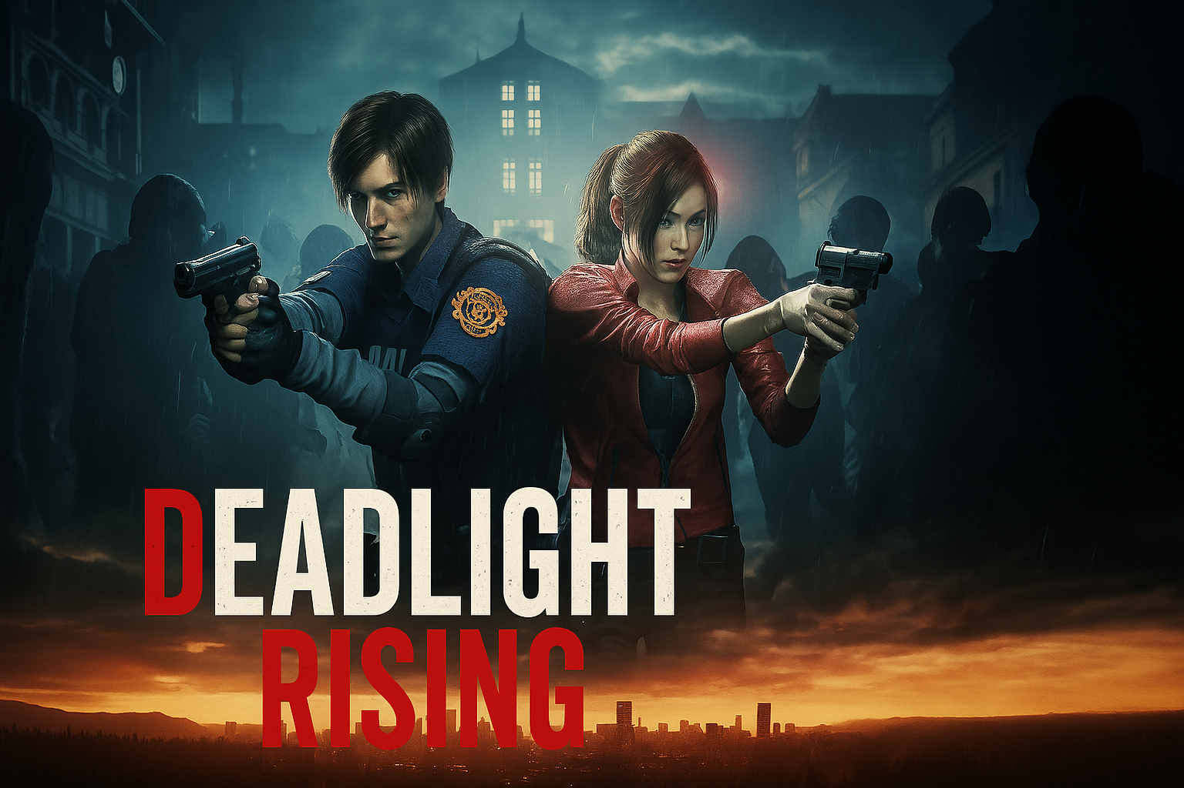

**Fig 1** : Game Cover

# **2 TOOLS AND TECHNOLOGIES USED**

The development of *Deadlight Rising* involved a variety of tools and technologies for designing the game world, programming the logic, creating animations, and building an interactive user interface. Below are the main tools and technologies used:

**Game Engine**

* **Unity 6.1**  
  The primary platform used to develop the entire game. Unity’s powerful features enabled 3D rendering, physics simulation, animation handling, and scene management.

**Programming Language**

* **C#**  
  All player, enemy, UI, and gameplay logic was scripted using C#. It provides strong object-oriented features and integrates seamlessly with Unity.

**Graphics & UI Tools**

* **TextMeshPro (TMP)**  
  Used to create advanced text-based UI like ammo count, mission timer, health bars, and dynamic messages such as “RELOADING…” and “OUT OF AMMO”.
* **Unity UI System**  
  Used to build interactive menus like the main menu, options panel, mission failed screen, and health displays.

**Animation**

* **Animator Controller in Unity**  
  Used to animate the zombies — including walking, chasing, attacking, and dying animations.

**Audio**

* Unity’s AudioSource and AudioClip components were used for:
  + Gunshots
  + Reloading
  + Zombie growls
  + Background Themes

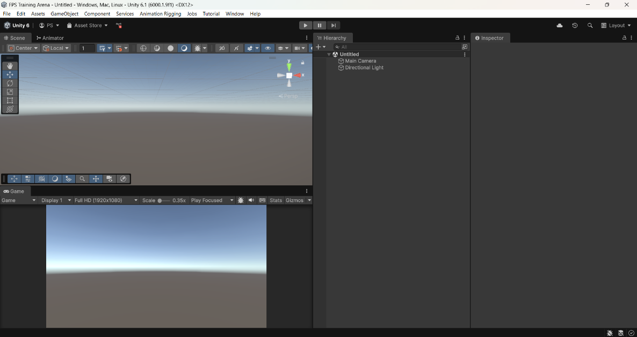

**Fig 2** : Unity Editor Screen

**Unity** is a powerful, cross-platform game engine developed by **Unity Technologies**. It is widely used for creating 2D, 3D, VR, and AR games and simulations. Unity is popular among both beginners and professionals due to its user-friendly interface, real-time editing capabilities, and extensive support for multiple platforms.

* **Released**: 2005
* **Current Version**: Unity 2022/2023+
* **Languages Supported**: C# (primarily), ShaderLab, JavaScript (deprecated)
* **Platforms**: Windows, macOS, Android, iOS, WebGL, PlayStation, Xbox, etc.

# **3 GAME OVERVIEW**

**Deadlight Rising** is a single-player first-person shooter (FPS) zombie survival game where the player must survive a 60-second mission against waves of zombie enemies in a hostile desert-like environment. The game is designed to test the player’s reflexes, resource management, and strategic decision-making under pressure.

**Core Gameplay Loop**

1. Player spawns with two weapons: **Rifle** and **Pistol**
2. Zombies detect and chase the player
3. Player must shoot zombies while managing **ammo** and **health**
4. Explosive barrels can be used to deal area damage
5. A **boss zombie** appears for the final challenge
6. Player either survives or faces **mission failure**

**Game Structure**

| **Component** | **Function** |
| --- | --- |
| Player Controller | First-person movement, sprinting, aiming, shooting, and weapon switching |
| Enemy AI (Zombies) | Patrol, detect player, chase, attack, and play death animation |
| Gun Mechanics | Fire rate, reload time, ammo count, audio effects |
| Timer System | Mission duration set to 60 seconds |
| Mission Fail Conditions | Player death, time over, or both guns out of ammo while zombies remain |
| UI System | Health bar, ammo count, timer, score, dynamic alerts |
| Boss Fight | Strong zombie with more health and a unique defeat screen |

**Winning Criteria**

* Player must eliminate **all zombies**, including the **boss**, before the timer ends.
* Must survive with at least one gun having ammo and the player’s health above 0.

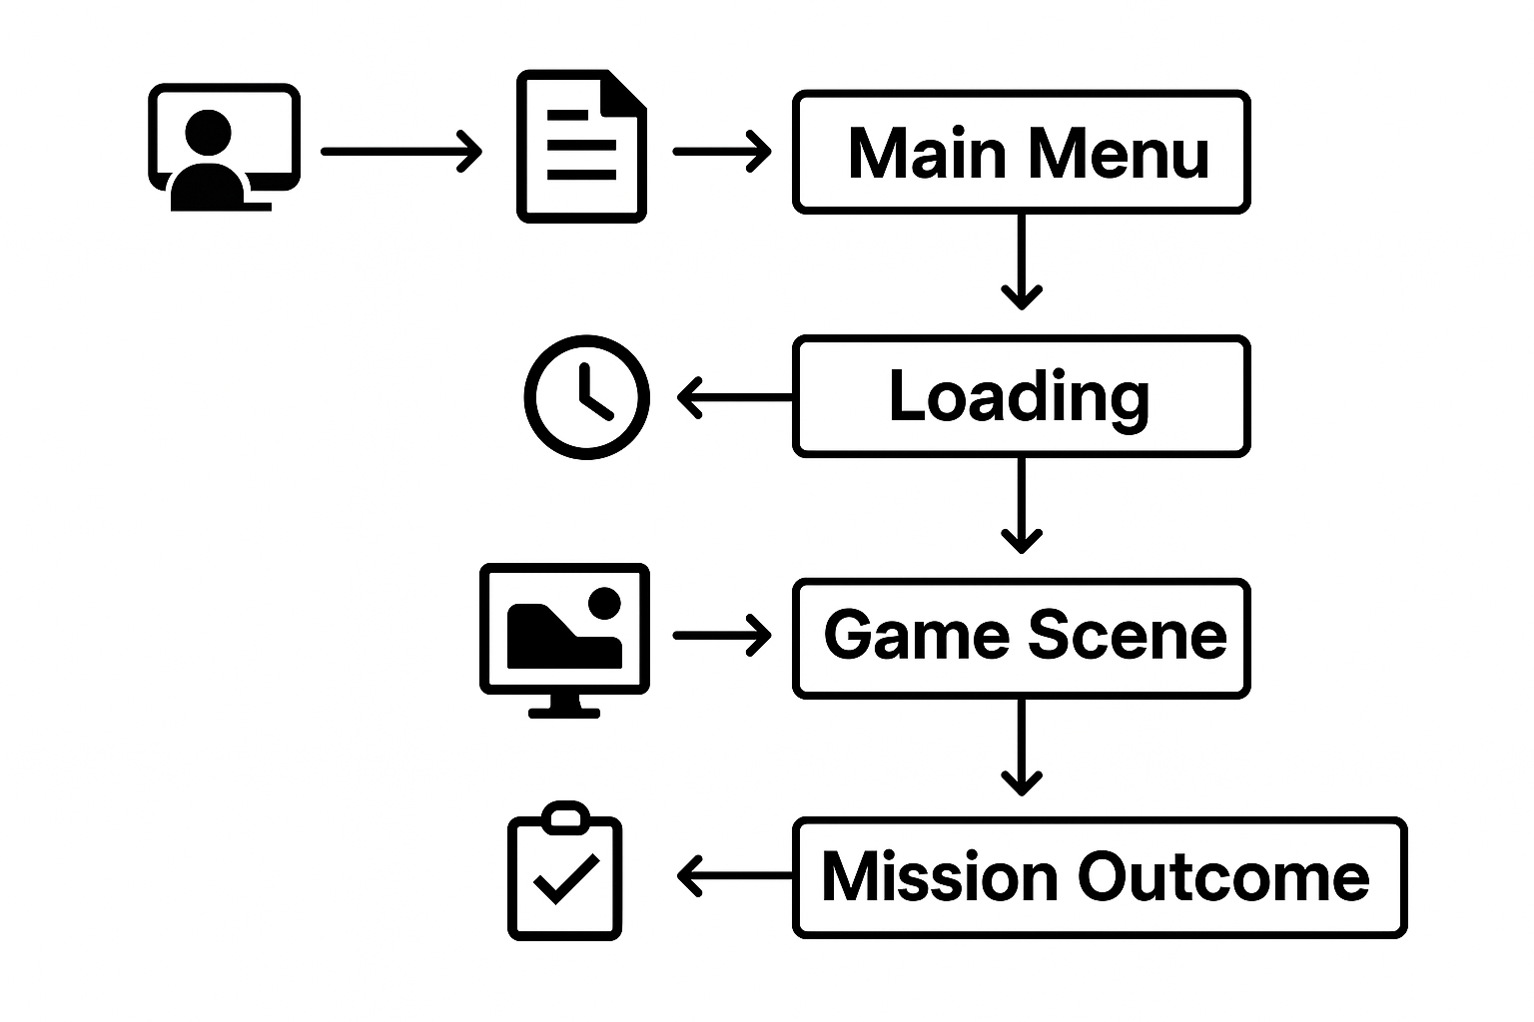

# **Fig 3 :** Flowchart Of Game Overview

# **4 INTRO SCENE**

Before reaching the Main Menu, *Deadlight Rising* begins with a **cinematic intro screen**. This screen sets the tone and introduces the player to the world of the game.

**Intro Scene Features**

* Game title: **Deadlight Rising**
* Message: **“Press Any Button to Continue”**
* Atmospheric background (e.g., desert ruins, fog, or burning environment)
* Background music or ambient zombie sounds (optional)

**Technical Details**

* A **UI Canvas** is used with:
  + Title text (TextMeshProUGUI)
  + Prompt text (e.g., blinking “Press Any Button”)
* Player input is detected using:

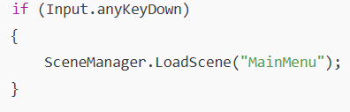

**Design Purpose**

* Prepares the player mentally before jumping into gameplay
* Gives cinematic feel similar to AAA zombie games

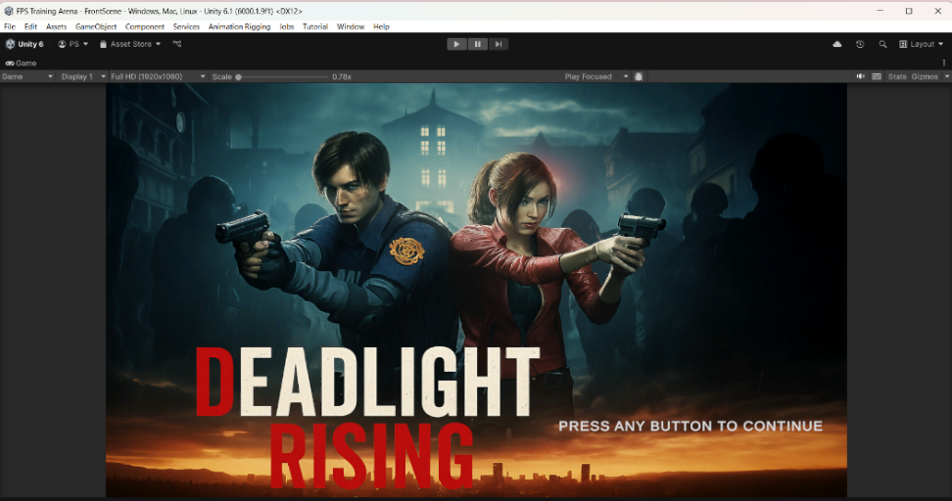

**Fig 4** : Game Intro Screen

# **5 MAIN MENU**

The **Main Menu** is the first interactive screen the player sees after the intro scene. It provides access to key navigation options such as starting the game, adjusting settings, or exiting the application.

**Main Menu Options**

| **Button** | **Function** |
| --- | --- |
| **Play** | Loads the next scene (usually a loading screen, then the gameplay scene) |
| **Options** | Opens the settings panel for sound and control instructions |
| **Exit** | Closes the application |

**Design Details:**

* Built using **Unity UI Canvas**
* Buttons use **Button component** with **OnClick()** event triggers
* Custom background image enhances the zombie survival theme
* TMP text is used for button labels for sharper UI

**Implementation:**

* All menu buttons are connected to a script (e.g., MainMenuManager.cs)  
  Example: SceneManager.LoadScene("LoadingScreen"); is triggered when **Play** is clicked.
* Exit button uses Application.Quit(); for closing the game

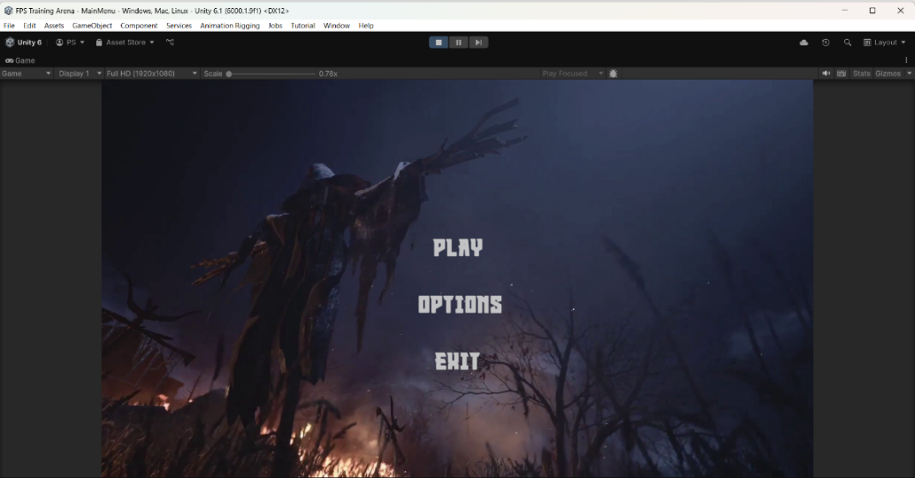

**Fig 5** : Main Menu Screen

# **6 GAME SCENE ENVIRONMENT**

The main gameplay of *Deadlight Rising* takes place in a custom-designed desert battlefield. The environment is designed to enhance the post-apocalyptic atmosphere while supporting zombie AI navigation and player movement.

**Environment Design**

* The scene is built using Unity’s **Terrain tools**, **3D models**, and **game objects** such as:
  + Desert ground texture
  + Abandoned props (boxes, fences, destroyed objects)
  + Explosive barrels
  + Zombie spawn points
* Lighting is adjusted to create a dramatic, gritty tone using **Directional Light**, **shadows**, and **fog**.

**Gameplay Layout**

* **Player Spawn Point**: Center of the map with visibility around
* **Zombie Spawn Points**: Spread around the outer areas to simulate surrounding threat
* **Explosive Barrels**: Strategically placed near chokepoints for tactical gameplay
* **Boss Zone**: An open area where the final boss zombie appears

**Navigation Details**

* The map supports free first-person movement
* No NavMesh is used — zombie movement is fully script-based
* Collision and object placement is optimized for smooth performance

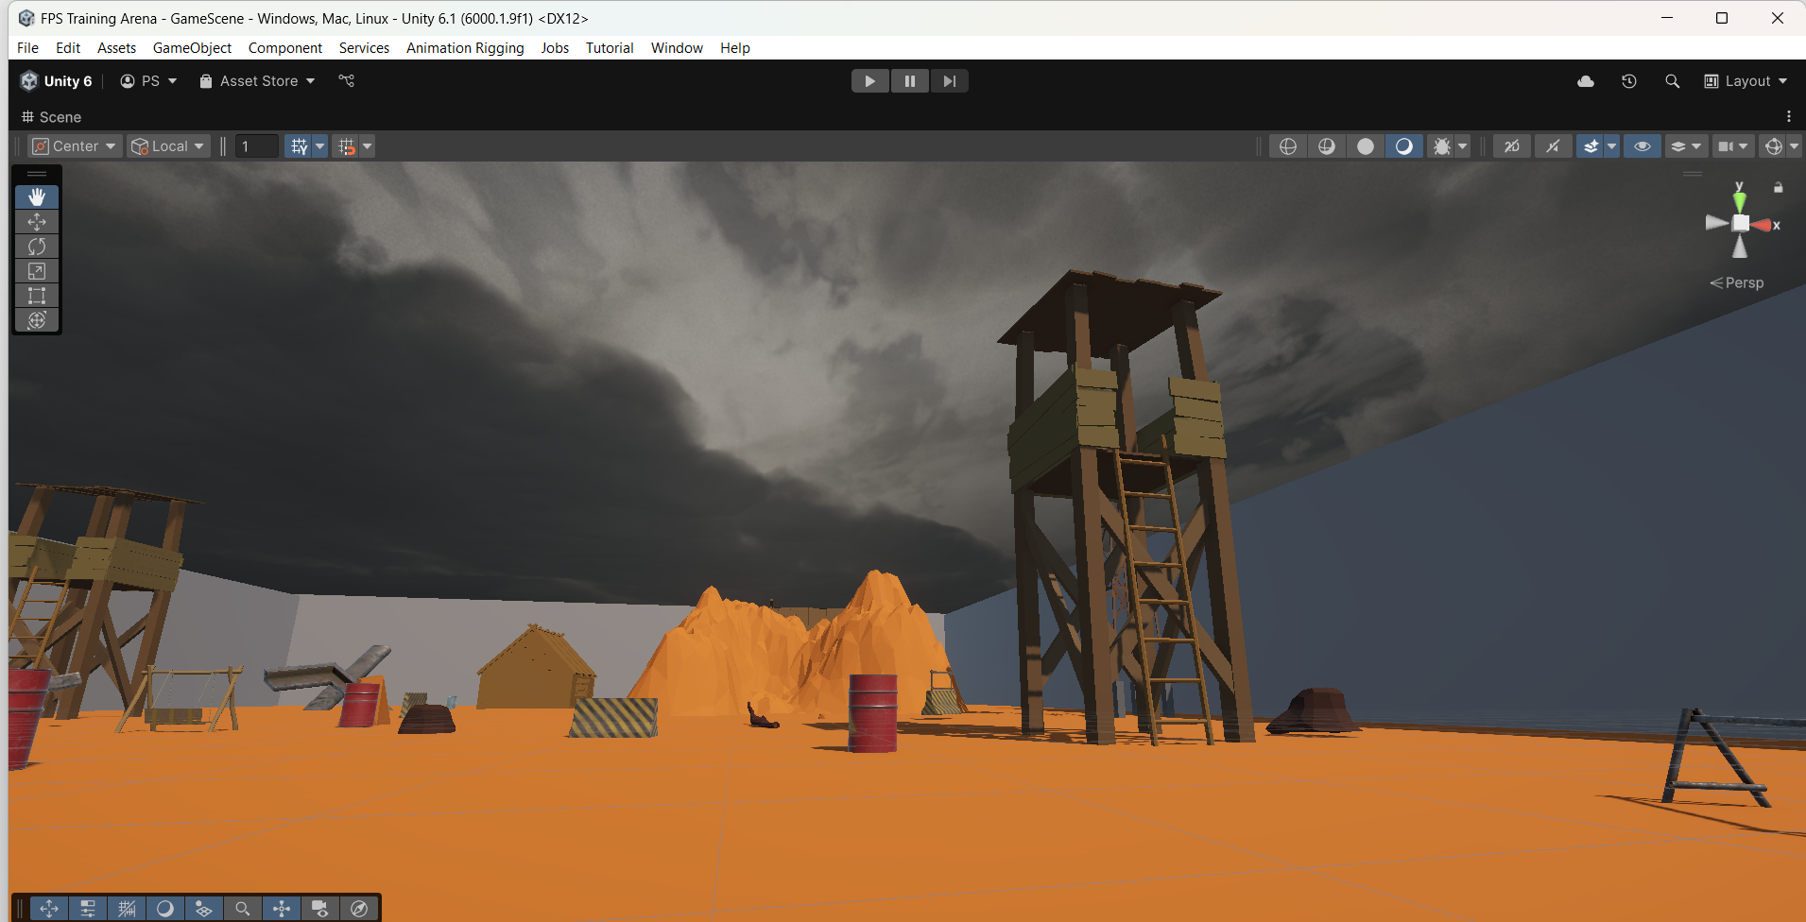

**Fig 6.1** : Environment of Level 1

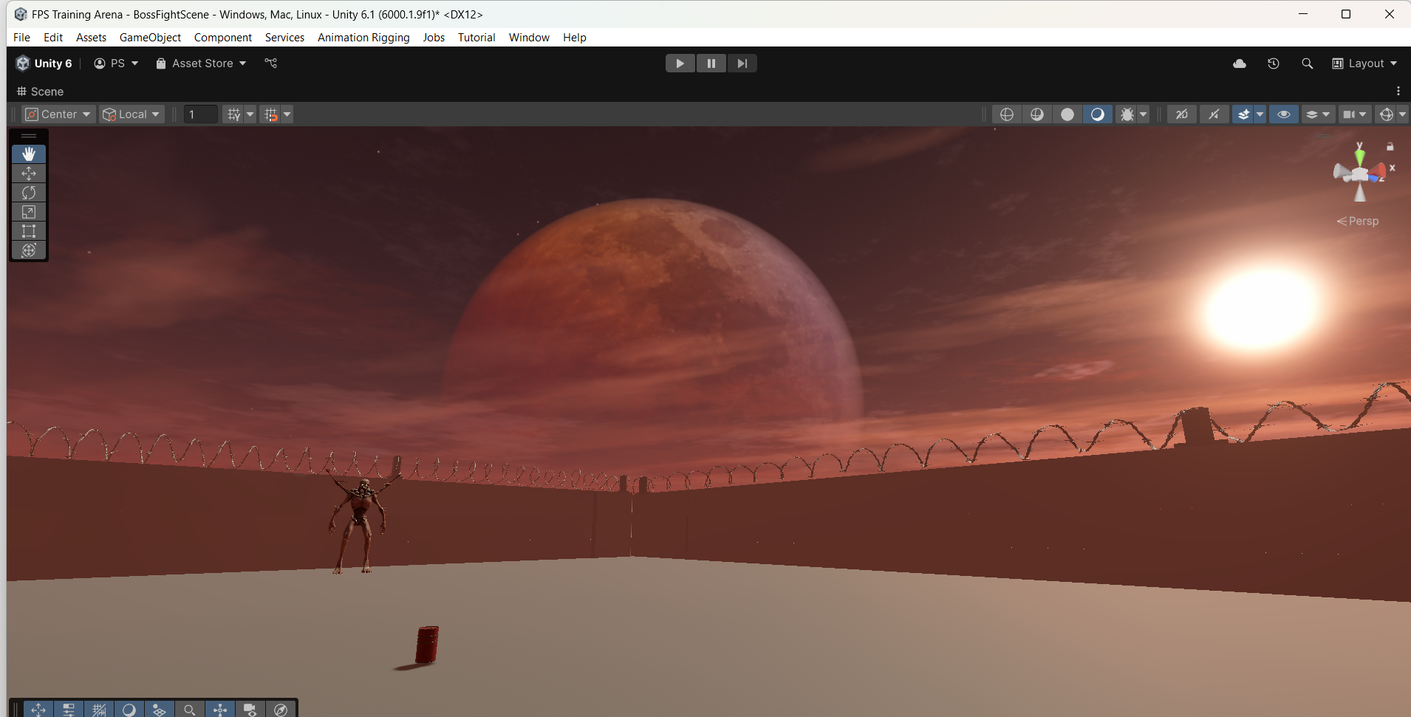

**Fig 6.2** : Environment of Level 2 (Boss Level)

# **7 PLAYER MECHANICS**

The player in *Deadlight Rising* controls a fully functional **First-Person Shooter (FPS)** character. Movement, combat, and survival are all managed through intuitive controls and realistic mechanics.

**Controls & Movement**

* **W, A, S, D** – Move Forward, Left, Backward, Right
* **Shift** – Sprint (increases speed temporarily)
* **Spacebar** – Jump
* **Right Click** – Weapon AimDownSight (ADS)
* **C** – Crouch
* **Mouse Movement** – Look around
* **Left Click** – Shoot
* **R** – Reload weapon
* **1 / 2 or Icon Tap** – Switch between Rifle and Pistol

**Health System**

* Player has a **Health Bar** shown on the UI
* Damaged by:
  + Zombie attacks
  + Explosive barrels (if too close)
* Health reaches **0 → triggers Mission Failed**

**Shooting Mechanics**

* Supports two weapons:
  + **Rifle** – High ammo, rapid fire
  + **Pistol** – Lower ammo, slower fire
* Each gun uses:
  + **Ammo count system**
  + **Reloading system**
  + **Gun sound effects**
  + **Bullet impact and fire rate handling**

**Key Features:**

* Integrated **FPS camera** for immersive experience
* Smooth transitions between walk and sprint
* Real-time damage system linked to enemy collisions

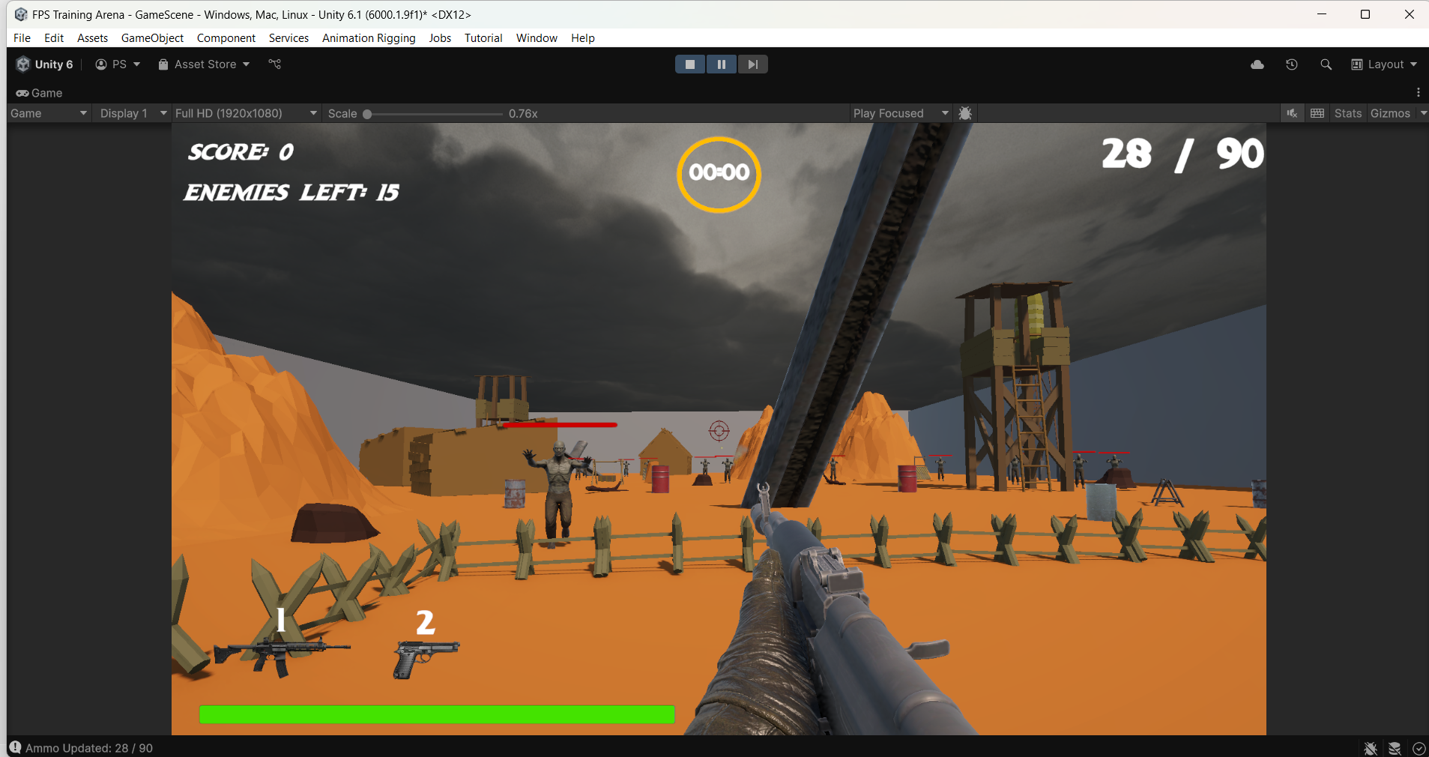

**Fig 7** : Player’s Perspective

# **8 GUN SWITCHING SYSTEM**

One of the key mechanics in *Deadlight Rising* is the ability to **switch between two weapons** — a **Rifle** and a **Pistol**. This system allows players to adapt to ammo shortages and tactical situations during combat.

**How Weapon Switching Works**

* The player starts with both weapons equipped.
* Switching can be done by:
  + Pressing **“1”** for Rifle
  + Pressing **“2”** for Pistol
  + Clicking on **gun icons** in the UI (like in PUBG or Call of Duty)
* Only one weapon is **active** at a time (the other is deactivated)

**Technical Implementation**

* Both weapons are child GameObjects of the player
* A **WeaponManager.cs** script handles:
  + Activating the selected weapon
  + Updating UI with correct ammo count
  + Playing proper reload and fire animations
* Weapon switching disables the currently active weapon’s GameObject and enables the selected one

**UI Design**

* Two gun icons appear at the bottom of the screen
* The current **ammo count** is displayed using **TextMeshProUGUI**

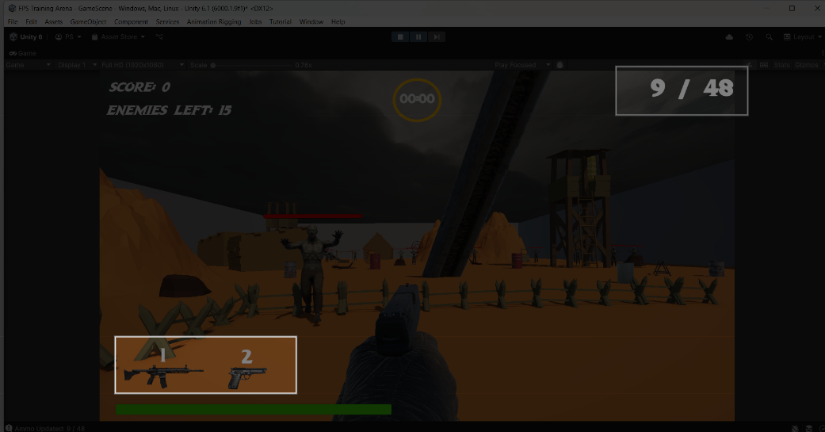

**Fig 8** : Gun Switching System

# **9 ZOMBIE ENEMY BEHAVIOUR**

Zombies are the core enemies in *Deadlight Rising*. They are programmed to detect, chase, and attack the player using custom **AI logic and animation states**. Their presence creates the main challenge for survival.

**Zombie AI Logic**

* **Detection Radius**: Zombies detect the player if within a certain distance
* **Chase**: When detected, zombies walk or run toward the player
* **Attack Radius**: When close enough, they stop and play an attack animation
* **Damage**: On contact, they reduce the player’s health

**Animation States**

Each zombie uses an Animator Controller with the following states:

* **Z_Walk** – Idle roaming or approach state
* **Z_Run** – When chasing the player
* **Z_Attack** – When close to player (within attack radius)
* **Z_FallingBack** – Triggered when zombie dies

These transitions are triggered using parameters like:

* Run (Trigger)
* Attack (Trigger)
* Die (Trigger)

**Health System**

* Each zombie has its own **EnemyHealth.cs** script
* Health reduces on bullet hit
* When health reaches zero:
  + Triggers death animation
  + Disables collider and behaviour

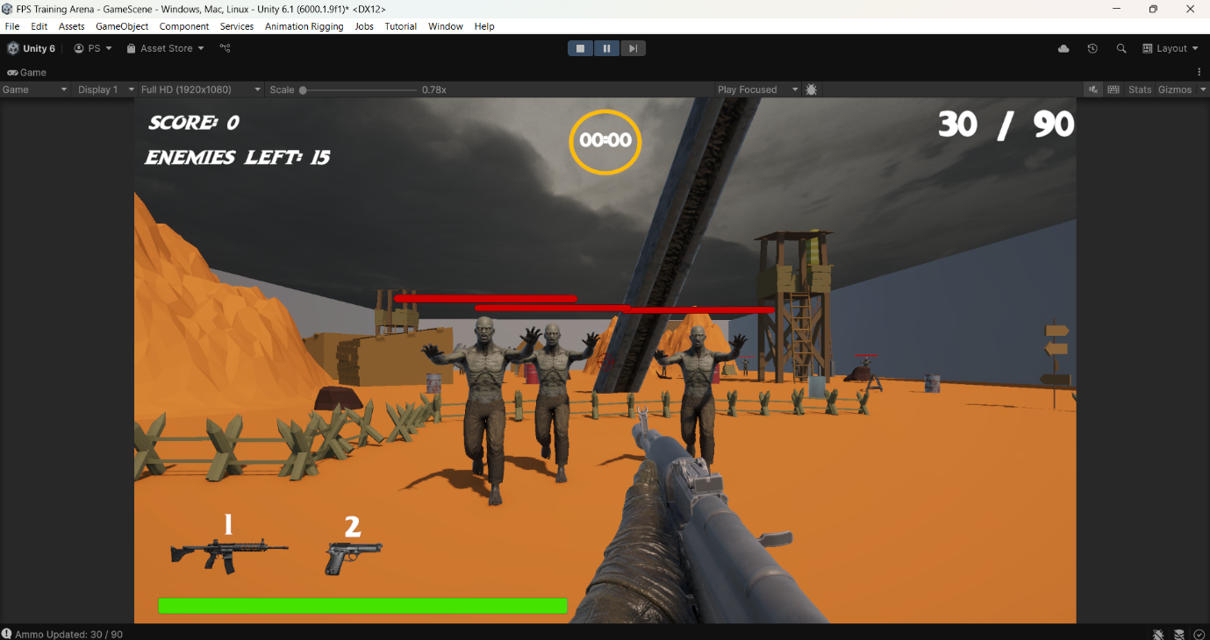

**Fig 9.1** : Zombie Behaviour

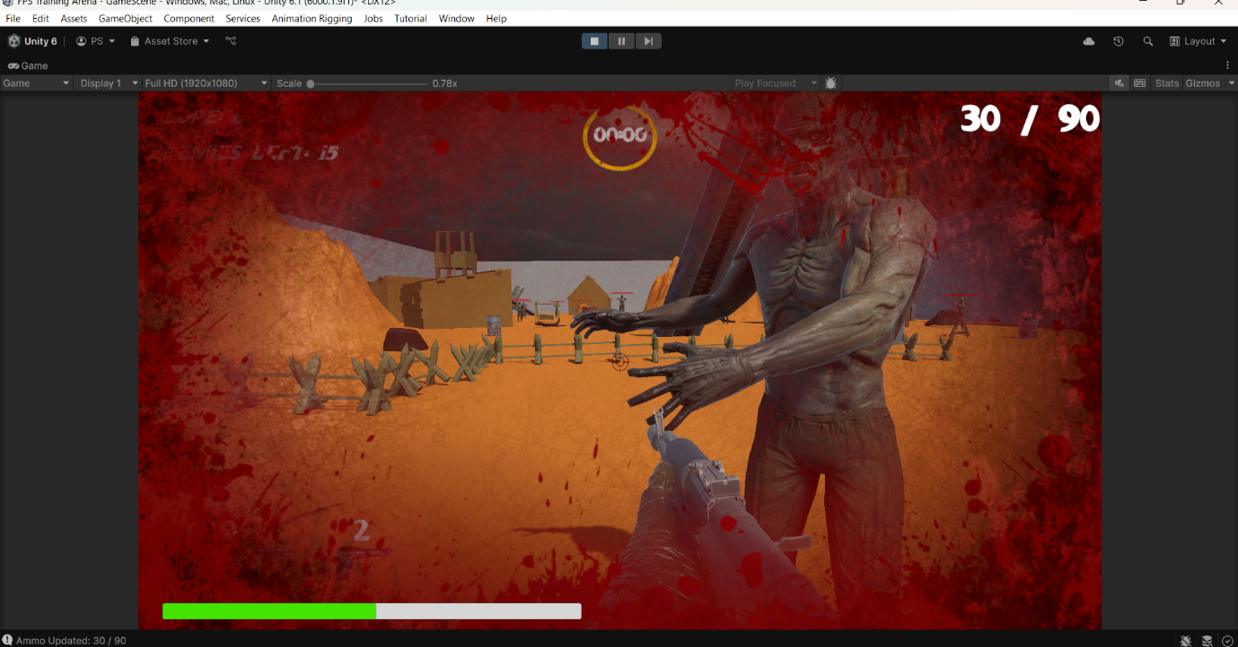

**Fig 9.2** : Player Hit Effect

# **10 BOSS ZOMBIE SYSTEM**

The **Boss Zombie** is the final and most powerful enemy in *Deadlight Rising*. It appears during the last phase of the game to create an intense climax and test the player’s skills under pressure.

**Boss Behaviour**

* Appears after a specific time or when other zombies are killed
* Has **higher health** than regular zombies
* Uses the same detection, chase, and attack logic — but with **stronger stats**
* Movement is faster or more aggressive (optional)

**Animation States**

The boss uses the same Animator Controller as regular zombies but may:

* Walk and run faster
* Have a slightly different attack animation (optional)
* Use the same **Z_FallingBack** animation when defeated

**Boss Defeat System**

* Boss has its own BossZombieHealth.cs script
* On death:
  + A special **"Boss Defeated" panel** is activated
  + Gameplay stops or transitions to win/end screen

**Damage & Combat**

* Boss can be killed using either the rifle or pistol
* Takes multiple bullets compared to normal zombies
* Can damage the player quickly if not avoided

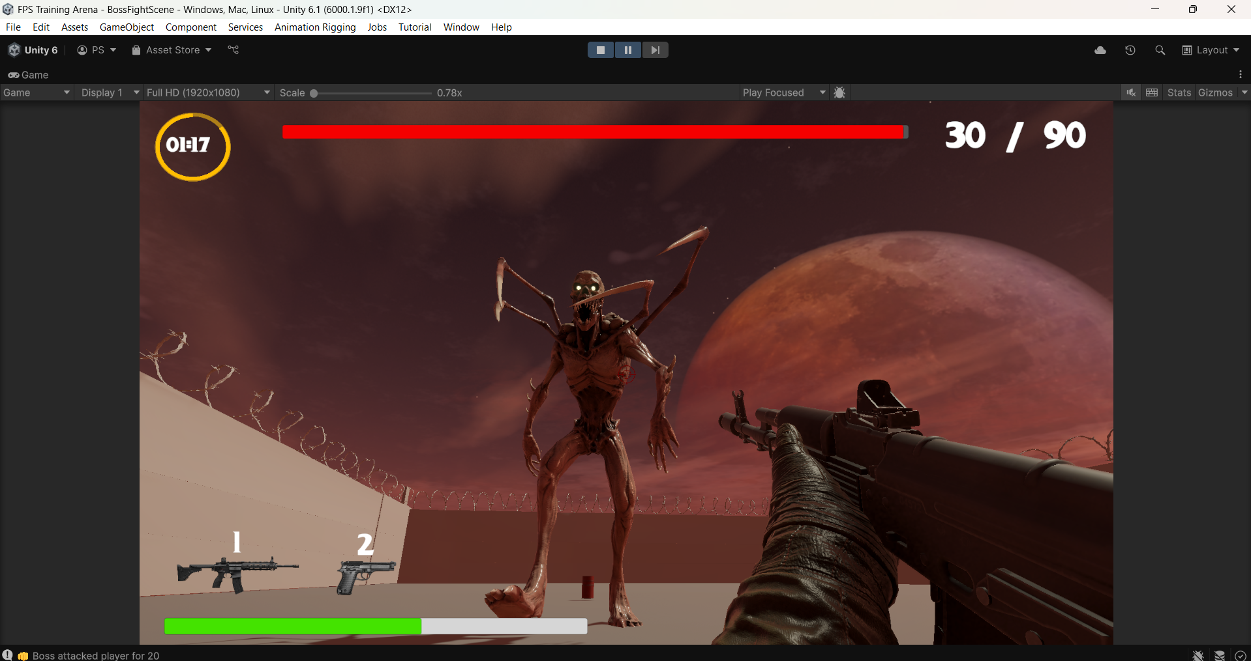

**Fig 10** : Boss Enemy Appearance

### **EXPLOSIVE BARREL AND FEATURES**

The explosive barrel detonates after being shot 3–4 times by the player.  
It deals 50% health damage to all zombies and the player within a blast radius.  
The barrel uses a health system to track bullet hits and triggers a visual explosion.  
Once exploded, it gets destroyed and can no longer be used.  
It's a tactical gameplay element that helps the player take down multiple enemies at once.

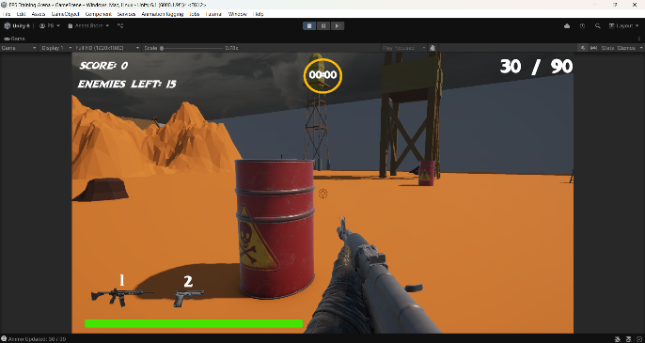 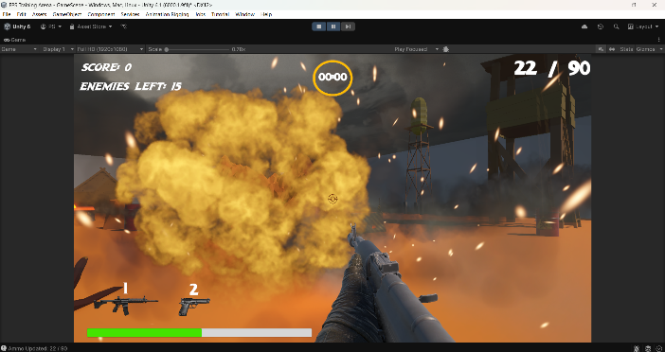

**Fig 10.1** : Explosive Barrels Showcase

# **11 UI ELEMENTS AND SCORING SYSTEM**

The User Interface (UI) in *Deadlight Rising* provides players with all essential information during gameplay, while the scoring system motivates players by tracking progress and performance.

**HUD (Heads-Up Display) Components**

| **Element** | **Purpose** |
| --- | --- |
| **Health Bar** | Shows player's current health. Reduces on enemy attack or barrel explosion. |
| **Ammo Count** | Displays current bullets for the equipped weapon (Rifle or Pistol). |
| **Weapon Icons** | Shows which gun is selected. Player can tap or press key to switch. |
| **Timer** | Counts down from 60 seconds – mission ends when it hits 0. |
| **“RELOADING…” Text** | Blinking TMP text shown during reload animation. |
| **“OUT OF AMMO” Text** | Blinking red TMP alert when current gun has no ammo left. |
| **Enemies Remaining** | Shows number of zombies left to defeat. |

**Scoring System**

* **Score Increases** each time a zombie is killed.
  + Normal zombie kill: 1 points
* The score is shown in the **top-right** corner of the screen (or as per your UI layout).
* The number of **remaining enemies** is displayed alongside the score or separately.

**Technical Implementation**

* All text UI elements use **TextMeshProUGUI**.
* The score is updated via script using: 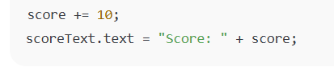
* Enemy count decreases when a zombie dies:

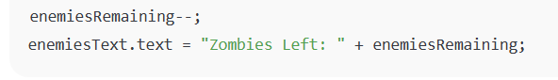

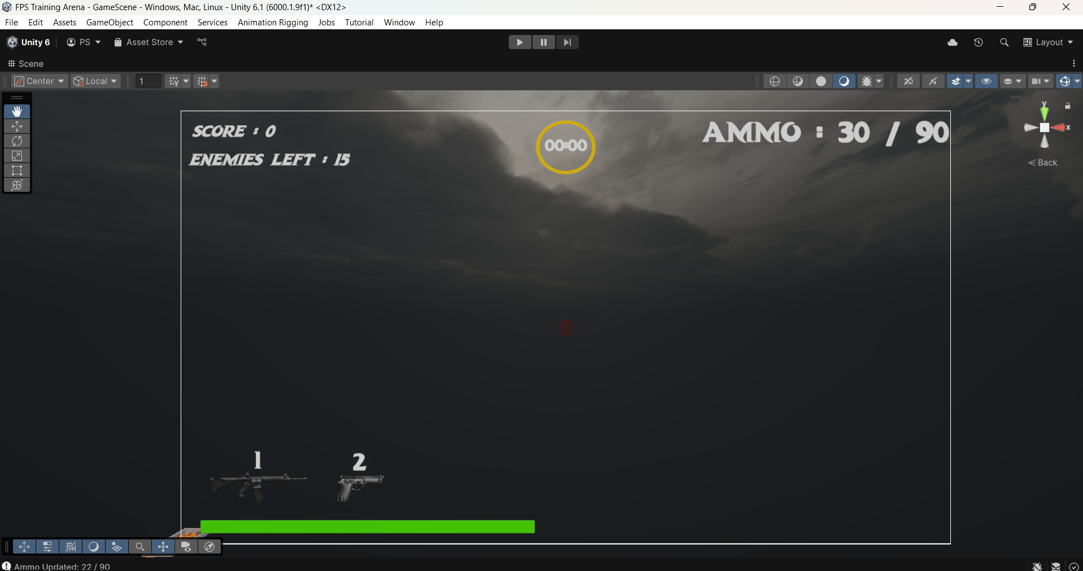

**Fig 11** : Gameplay UI Canvas

# **12 MISSION OUTCOME SYSTEM**

At the end of every round in *Deadlight Rising*, the game checks for one of two outcomes: **Mission Complete** (win) or **Mission Failed** (loss). Both results are triggered based on player performance, survival, and game rules.

**Mission Complete**

The mission is **successfully completed** if:

* All zombies (including the boss) are defeated
* Player is still alive
* At least one weapon has remaining ammo
* Timer has not yet expired

**Outcome:**

* A **“MISSION COMPLETE”** panel is displayed
* Timer and gameplay freeze
* (Optional) Final score or success message shown

**Mission Failed**

The mission **fails** under any of these 3 conditions:

| **Condition** | **Failure Reason Displayed** |
| --- | --- |
| Player Health = 0 | “Player is Dead” |
| Timer = 0 | “Time’s Up – Zombies Remain” |
| Both Guns Out of Ammo + Zombies Alive | “Out of Ammo but Zombies Remain” |

**Failure Screen:**

* “MISSION FAILED” image appears
* Below it, a **TextMeshProUGUI message** displays the dynamic reason for failure

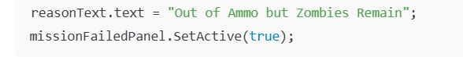

**Restart Option**

Both outcome screens include a **“Replay”** or **“Exit”** button:

* Replay reloads the current scene
* Exit returns to main menu or closes the game

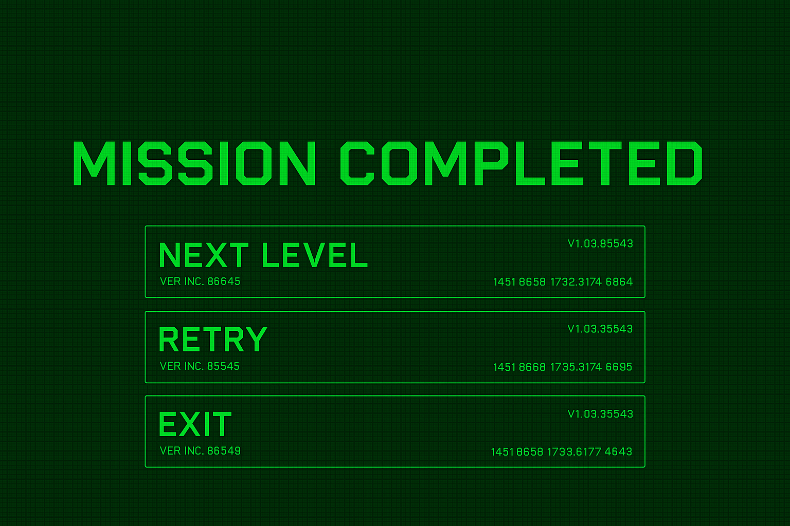

**Fig 12.1** : Mission Completed Panel

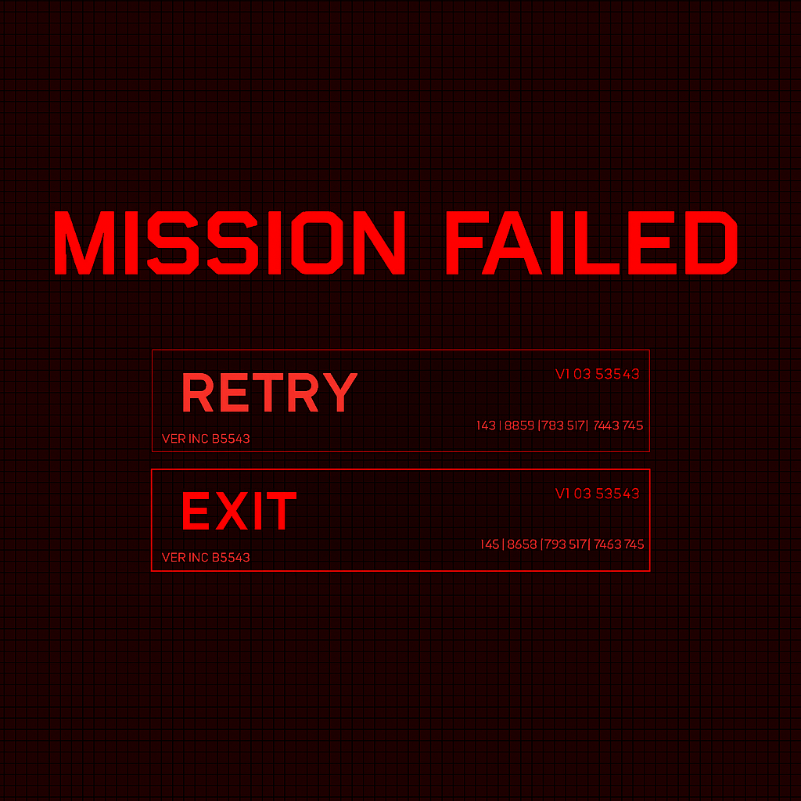

**Fig 12.2** : Mission Failed Panel

# **13 SCENE MANAGEMENT AND ANIMATOR**

This section explains how scene transitions and character animations are handled using Unity’s built-in systems — essential for the overall flow and immersive feel of the game.

## Scene Management

*Deadlight Rising* uses **four main scenes**:

| **Scene Name** | **Description** |
| --- | --- |
| **IntroScene** | Shows game title and "Press Any Button to Continue" |
| **MainMenuScene** | Allows access to Play, Options (if added), and Exit |
| **LoadingScene** | Temporary scene that appears between Main Menu and Game Scene |
| **GameScene** | Core gameplay scene – zombie survival battle takes place here |

**Transition Example:**

csharp

CopyEdit

SceneManager.LoadScene("MainMenuScene");

* Transitions occur on button click, key press, or after loading completion
* All scenes are added to **Build Settings**

## Animator Controllers

Unity's Animator Controller is used to handle animations for **Zombie** and **Boss Zombie** characters.

**Zombie Animator Structure**

Animator States:

* **Z_Walk** – Used when zombie is idle or moving without seeing player
* **Z_Run** – Triggered when chasing the player
* **Z_Attack** – Played when close enough to deal damage
* **Z_FallingBack** – Played upon death

Triggers in Animator:

* Run → switches to Z_Run
* Attack → switches to Z_Attack
* Die → plays Z_FallingBack and disables behaviour

**Transitions:**

* Conditions are set using SetTrigger("Attack") or SetTrigger("Die") from C# scripts
* Smooth blends make movement realistic

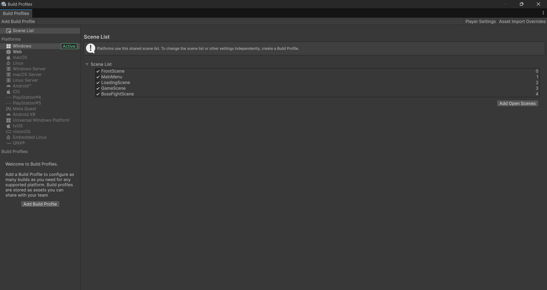

**Fig 13.1** : Scene Arrangements

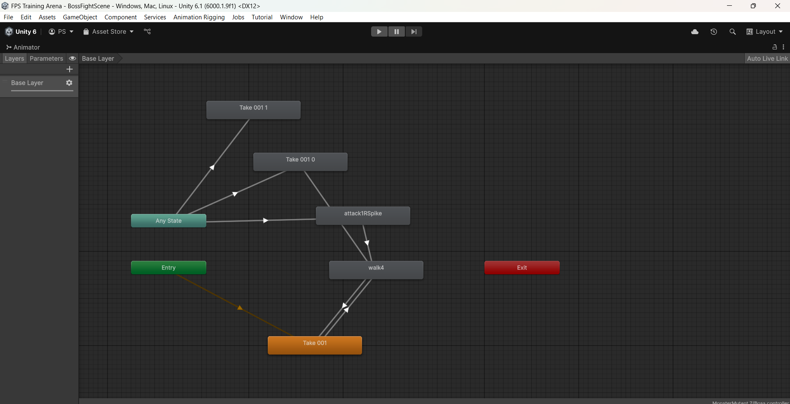

**Fig 13.2** : Animator Controller Arrangements

# **14 SCRIPT OVERVIEWS AND CHALLENGES FACED**

## Major Script Overviews

Your game relies on C# scripts to control all gameplay logic. Below are the key scripts with their responsibilities:

**PlayerShooting.cs**

* Handles firing input, ammo reduction, reloading
* Calls enemy health functions on bullet hit
* Updates UI elements like “RELOADING…” and “OUT OF AMMO”

**WeaponManager.cs**

* Switches between rifle and pistol
* Updates UI icons and ammo display
* Controls active weapon visibility

**ZombieBehavior.cs**

* Detects player with radius check
* Switches between walk, run, and attack animations
* Applies damage to player if in range

**EnemyHealth.cs / BossZombieHealth.cs**

* Reduces health when hit
* Triggers death animation and disables colliders
* Boss script triggers “Boss Defeated” panel on death

**MissionFailManager.cs**

* Checks for fail conditions:
  + Timer = 0
  + Health = 0
  + Both guns out of ammo + zombies still alive
* Displays mission failed screen with proper reason

**GameTimer.cs**

* Countdown from 60 seconds
* Stops game on 0 and checks win/fail status

## Challenges Faced During Development

**1. FPS Camera Not Working in New Scene**

* Issue: Copied player from another scene, camera wasn’t active
* Fix: Manually reassign camera to FirstPersonController and tag as “MainCamera”

**2. Zombie Sinks Under Terrain**

* Issue: Zombie model’s pivot point caused it to drop underground
* Fix: Reset pivot in Blender or add an empty parent object in Unity and reposition

**3. Gun Not Switching Properly**

* Issue: One gun didn’t deactivate when switching
* Fix: Scripted both weapons to toggle active state using SetActive(true/false)

**4. Explosive Barrel Not Damaging Zombies**

* Issue: Damage not applied on explosion trigger
* Fix: Used Physics.OverlapSphere to detect all colliders in range and apply damage

**5. UI Not Updating Ammo Properly**

* Issue: Ammo count stayed static after shooting
* Fix: Added real-time ammoText.text = currentAmmo.ToString(); inside Update()

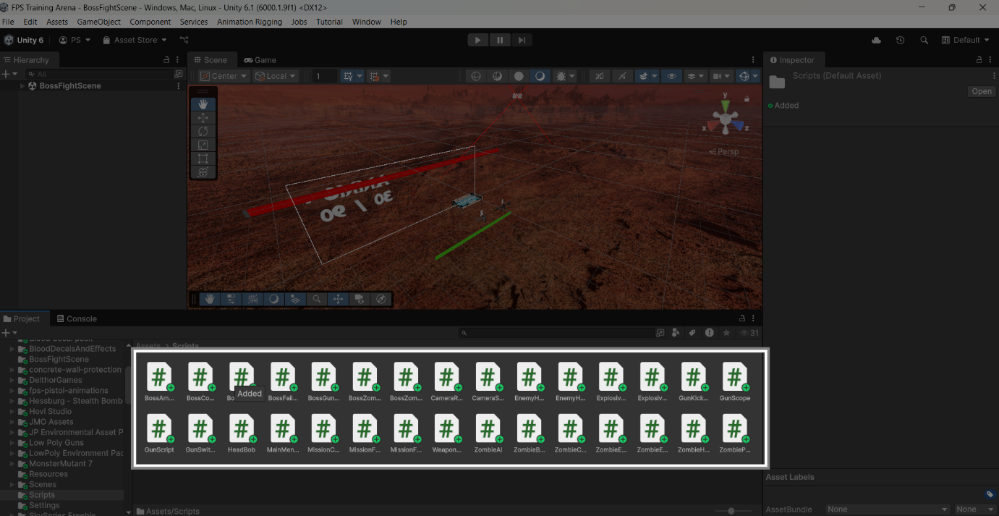

**Fig 14.1** : Script Overviews

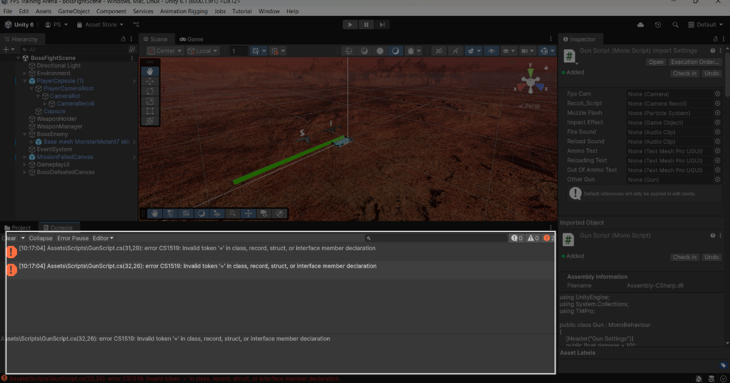

**Fig 14.2 :** Debugging Errors

# **15 FUTURE ENHANCEMENTS**

While *Deadlight Rising* is a fully functional FPS zombie game, there are many ways it can be improved and expanded in future versions. These enhancements can elevate the gameplay, make it more dynamic, and provide players with deeper content and replayability.

**1. Multiplayer Co-op Mode**

* Add support for 2+ players to survive together
* Synchronize enemy AI, health, and actions across network using Photon or Unity Netcode

**2. Storyline and Cutscenes**

* Add intro cutscene and narrative dialogues
* Include character backstory and mission objectives for deeper engagement

**3. More Zombie Types**

* Introduce fast zombies, crawlers, poison zombies, etc.
* Each type has unique behaviour and requires different strategies

**4. Weapon Upgrades**

* Let players collect or unlock weapon upgrades like:
  + Laser sights
  + Damage boosters
  + Extended magazines
* Include UI to choose upgrades

**5. Save/Load System**

* Allow players to save progress, score, and settings
* Reload from checkpoints or previous levels

**6. Cloud Deployment or WebGL Build**

* Export the game to WebGL and host it online
* Let friends and others play from a browser without installing

**7. Dynamic Sound System**

* Add random zombie growls, footstep audio, ambient sounds
* Adjust volume based on distance to make it more realistic

**8. Mobile Version**

* Optimize UI, input, and performance for Android/iOS devices
* Add on-screen controls instead of keyboard/mouse

# **16** **CONCLUSION**

*Deadlight Rising* was developed as a complete first-person zombie survival shooter using the Unity game engine. From designing immersive environments and scripting complex enemy behaviours to building interactive UI systems and mission logic, this project showcased a wide range of game development skills.

The gameplay blends action, strategy, and time-bound survival to offer an engaging experience. With a clean UI, functional weapon mechanics, enemy AI, and mission outcome system, this game represents a solid foundation for further development and expansion.

This project not only strengthened our technical knowledge of C# and Unity but also taught us valuable lessons in problem-solving, time management, and design thinking. It proves that with consistency, creativity, and iteration, even indie developers can create polished gaming experiences.

## 

## **Acknowledgements**

We would like to express our sincere thanks to:

* **Reegan,** our project guide, for continuous support, technical feedback, and motivation throughout development.
* **Our teammates/friends**, for testing the game, reporting bugs, and giving suggestions.
* **Online tutorials, forums, and documentation**, especially the Unity and C# communities, for helping us resolve issues and learn new things.

Finally, we are proud of what we've built — and excited about where it can go in the future.